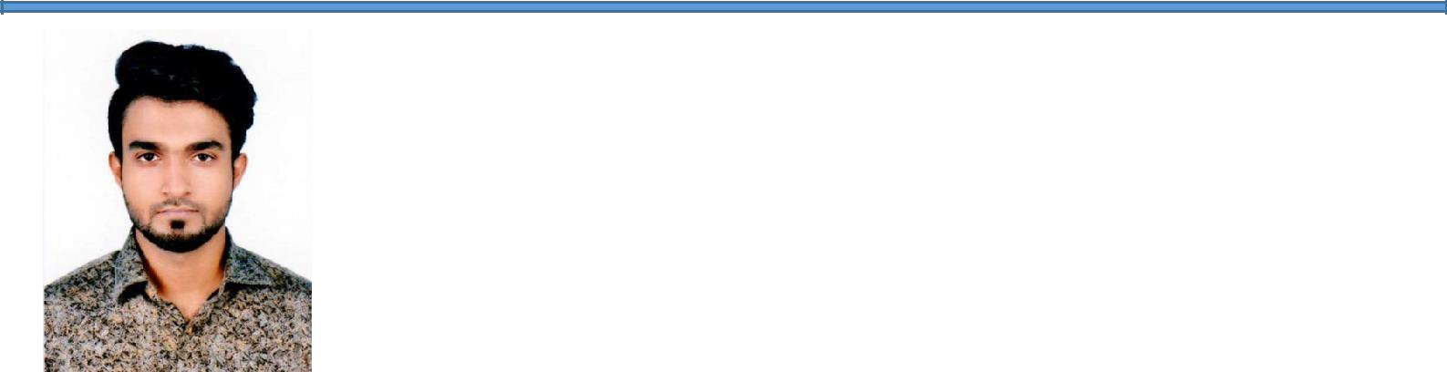

**Sk Al Zaminur Rahman**

|  |  |
| --- | --- |
| [alzaminurr@gmail.com](mailto:alzaminurr@gmail.com) | Road no -03, House no -16, Block-A, Mirpur-1, Dhaka-1216. |
| **Phone**:01682701431 |  |
| [github.com/zami40](https://github.com/zami40) | [In/al/zaminurr](https://www.linkedin.com/in/al-zaminurr/) |

OBJECTIVES

A passionate human being who is optimistic, hard-worker and team player,dedicated to learn new things and very much eager to explore new technologies. Seeking a position in software industry as software engineer or backend developer by utilizing skills and knowledge.





**EDUCATION**

|  |  |
| --- | --- |
| **2014-2018:** | Bachelor in Computer Science & Engineering, Khulna University |
| **2010-2012:** | HSC, BCIC School & College, Dhaka. Result: G.P.A: 5.00 from Science division. |
| **2010:** | SSC, BCIC College, Dhaka. Result: G.P.A: 5.00 from Science division. |



**TECHNICAL SKILLS**



**Programming** Java, Python C++,C, PHP

# Languages:

**Frameworks and others:** SpringBoot framework(Java),django-framework(python),node-js,MySQL ,Sqlite,HTML5, CSS3, VanilaJS, Bootstrap,Pandas, Selenium,Postman,Maven,ASP.net,Codeblocks,VsCode, Matlab, Eclipse, Pycharm, Sublime text.

**Operating** Windows,Linux.

# Systems:



**EXPERIENCES**

**Currently Working(from August,2022-Now): Software Engineer,** [**Dohatec New Media**](http://dohatec.com/) **(March-July,2022):** Junior Software Engineer[,Swosti Limited](https://swosti.net/).

**March-Aug,2019:** SQA (intern) at [Misfit Technolgies.](https://misfit.tech/)





**Job Duties & Responsibilities**

# 

# SE at Dohatec:

# Working at Dohatec CA team as as software engineer.

# JSE at Swosti Limited:

1.Doing assigned backend task in vaadin 2.Doing assigned frontend task in vaadin 3.Using MySql and Sqlyog to operate DB 4.Using Svn to handle files and versioning them

1. Using Jasper Report to generate report and update

# SQA at Misfit Technologies:

* 1. Finding Error and software issues by checking with proper methods 2.Generating reports with a certain template for future reference 3.Collaborating with developer and business team to give better solutions. 4.Implementing ideas during testing and use technological tools properly. 5.Familiar with softwares like trello, jira, google document, excel etc.



**RESEARCH**

**Soil classification using Machine Learning Methods and Crop Suggestion Based on Soil Series.** (Published at the ICCIT (International Conference on Computer and Information Technology) conference 2018).

It has been awarded **the best paper of the session in ict and development category** at the conference. Link - [ICCIT-2018](https://ieeexplore.ieee.org/document/8631943)

Methods: k-Nearest Neighbor (k-NN), Bagged Trees, and Gaussian kernel based Support Vector Machines (SVM).





**ACHIEVEMENTS**

**Certification:** From 2020 and afterwards completed specialization from Coursera.

[https://www.coursera.org/specializations/web-design.](https://www.coursera.org/specializations/web-design) <https://www.coursera.org/specializations/web-applications>. [https://www.coursera.org/learn/sql-for-data-science.](https://www.coursera.org/learn/sql-for-data-science) <https://www.coursera.org/learn/django-database-web-apps/home/welcome>

**Certificates link**: [WebDesign ,](https://www.coursera.org/account/accomplishments/verify/RTS57G3D2TXQ) [WebApplicationForEverybody](https://www.coursera.org/account/accomplishments/specialization/LKJZULHN3AZ5) , [SqlForDataScience](https://www.coursera.org/account/accomplishments/verify/NSU4UUSSTQHL) and [Web Application](https://www.coursera.org/account/accomplishments/certificate/PTFDAJFBU5LT) [Technologies and Django**.**](https://www.coursera.org/account/accomplishments/certificate/PTFDAJFBU5LT)

# Dec, 2018: Thesis paper published at the ICCIT conference 2018 and won the best paper award in ICT and Development session.

**May, 2016:** Winner at Make-A-Thon with team Alpha-Omega (A technical team formed by KU students).

**Feb–Aug,2018:** General Secretary at CLUSTER (Khulna University IT club).

**2008:** Junior Scholarship, general grade.





**PROJECTS**

**Restaurant Management App:** It is an restaurant site where several types of food items are offered to be sold. One can open an account as User or admin, user can upload their information, select food item and add to cart multiple food items for order, admin can add/remove food items and their prices. **Developed it with django,sqlite,** <https://github.com/zami40/CMA1>

**A CMS (Content Management System):** It is an e-commerce site where several types of items are offered to be sold. One can open register an account, select item and add to cart multiple items. **Responsible for checking the requirements, processes and additional coder**. Developed with ASP.net and C#.

**Smartex Super Shop Management System:** It is a software management system for Smartex super shop. It deals with inventory products, sales and update new products. It also keeps track about employees, their information, salary etc. **An additional coder, responsible for checking and fulfilling requirements and demands**. Developed with PHP.

**File Folder Management System:** Basically, it is a file folder management system under a big project called varsity management system. It receives file from another page keep track and passes them to another page. Developed in Simtyre (A framework) with PHP.





**HIGHLIGHTS**

**Communication:** Speaking, writing, listening and presenting ideas effectively. **Research &** Identifying and solving problems, predicting and evaluating solutions. **Planning:**

**Human** Inspiring, sharing credit and delegating with respect.

# Relations:

**Organization &** Leading and mentoring if possible, Coordinating tasks.

# Leadership:

**Work Ethic** Accepting responsibilities, making decisions, Completing tasks.





**REFERENCES**

|  |  |  |
| --- | --- | --- |
| Dr. Kamrul hasan Talukdar | Al Zihanur Rahman | S.M. Mohidul Islam (Thesis Supervisor) |
| Professor, Khulna University, Contact No: +8801925687763,  E-Mail: [khtalukder@gmail.com](mailto:khtalukder@gmail.com) | Head of Communications, BCSUS.  E-mail: [zihanurr@gmail.com](mailto:zihanurr@gmail.com) | Assistant Professor, Khulna University, Contact No: +8801727043774,  E-Mail: [mrx@cseku.ac.bd.](mailto:mrx@cseku.ac.bd) |